Part 1: create EC2 Instances
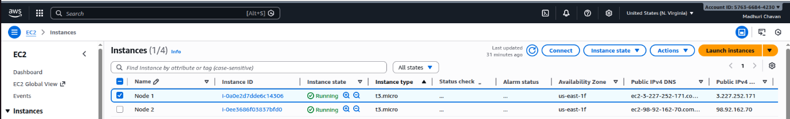
PART 2: Local Machine
.PEM file Give permissions
chmod 400 ~/Downloads/ansible-key.pem
Connect SSH to EC2
ssh -i ~/Downloads/ansible-key.pem ubuntu@<EC2_PUBLIC_IP>
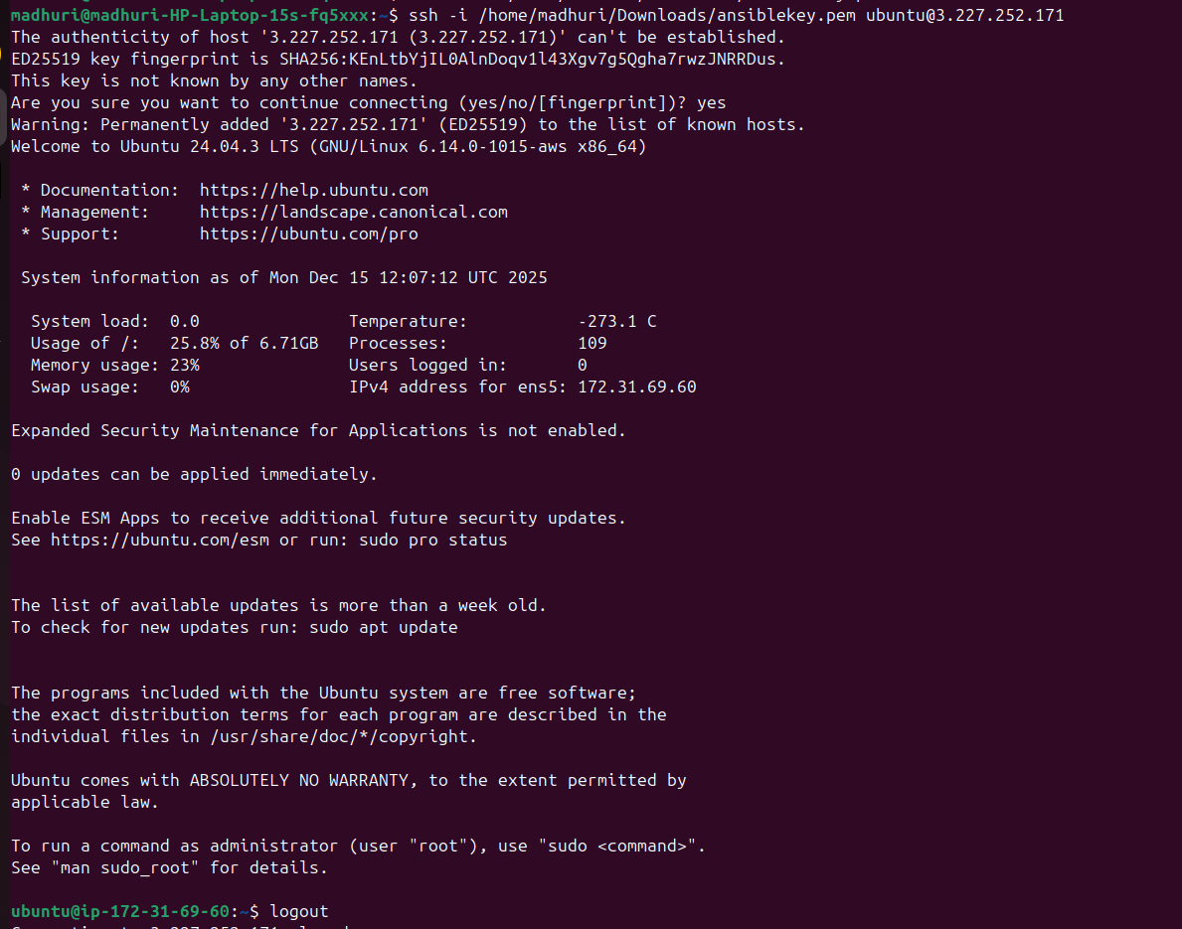
PART 3: Pass wordless SSH For Ansible
On Local machine generate Ansible key
ssh-keygen -t rsa -b 4096 -f ~/.ssh/id_rsa_ansible
Enter → Enter (passphrase blank)
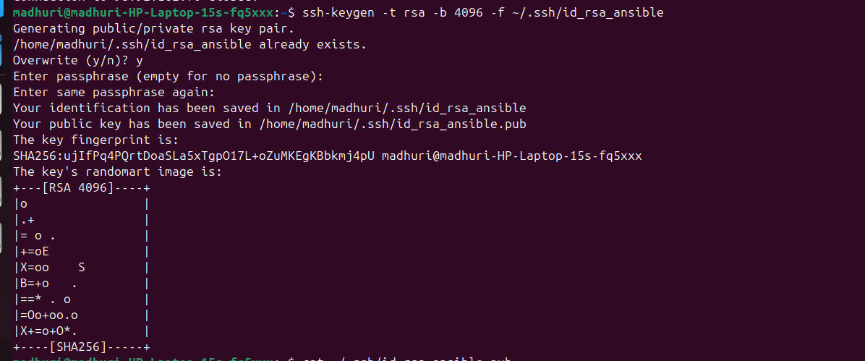
On EC2 add
In EC2 (already logged in)
mkdir -p ~/.ssh
chmod 700 ~/.ssh
nano ~/.ssh/authorized_keys

Local machine:
cat ~/.ssh/id_rsa_ansible.pub
copy output in EC2’s ~/.ssh/authorized_keys
Save (Ctrl+O, Enter, Ctrl+X)
chmod 600 ~/.ssh/authorized_keys

Pass wordless SSH test
Local machine
ssh -i <Path_.pem_file> ubuntu@<EC2_PUBLIC_IP>
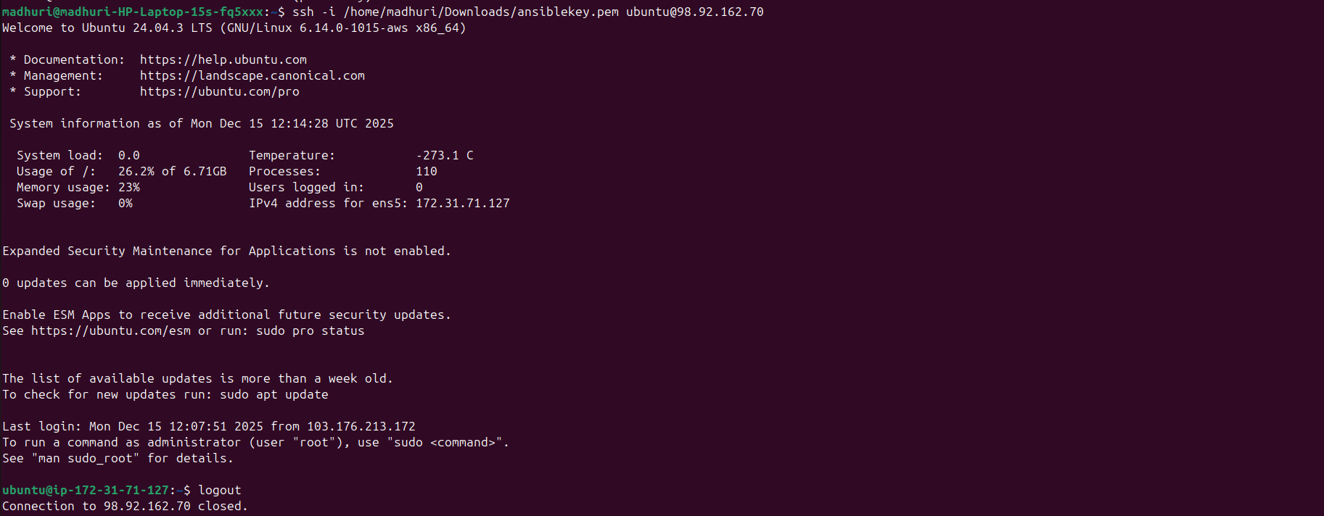
PART 4: Ansible Inventory
Create inventory.ini → add
[servers]
<EC2_PUBLIC_IP> ansible_user=ubuntu ansible_ssh_private_key_file=/home/madhuri/.ssh/id_rsa_ansible
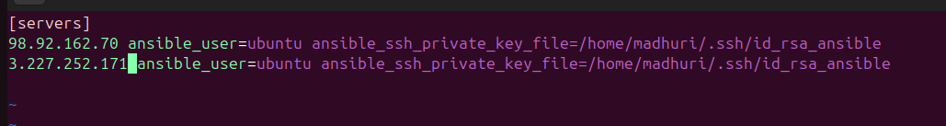
Ansible Ping Test
ansible -i inventory.ini -m ping all
✔️ Output:
SUCCESS => "pong"
